### Introduction to Devops ###
- Any application/ feature released faster to the market will have business advantage
- People/Teams responsible for doing this should be paid decently.
- DevOps is all about deploying your application quickly/faster to the market.
- Let’s understand how the applications are deployed
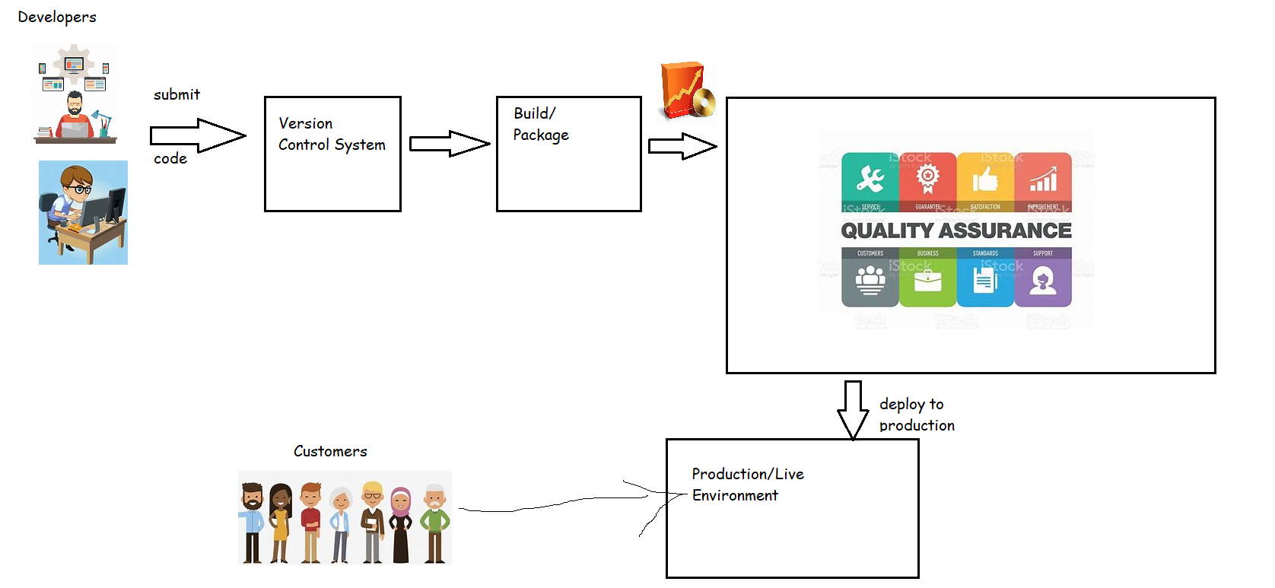
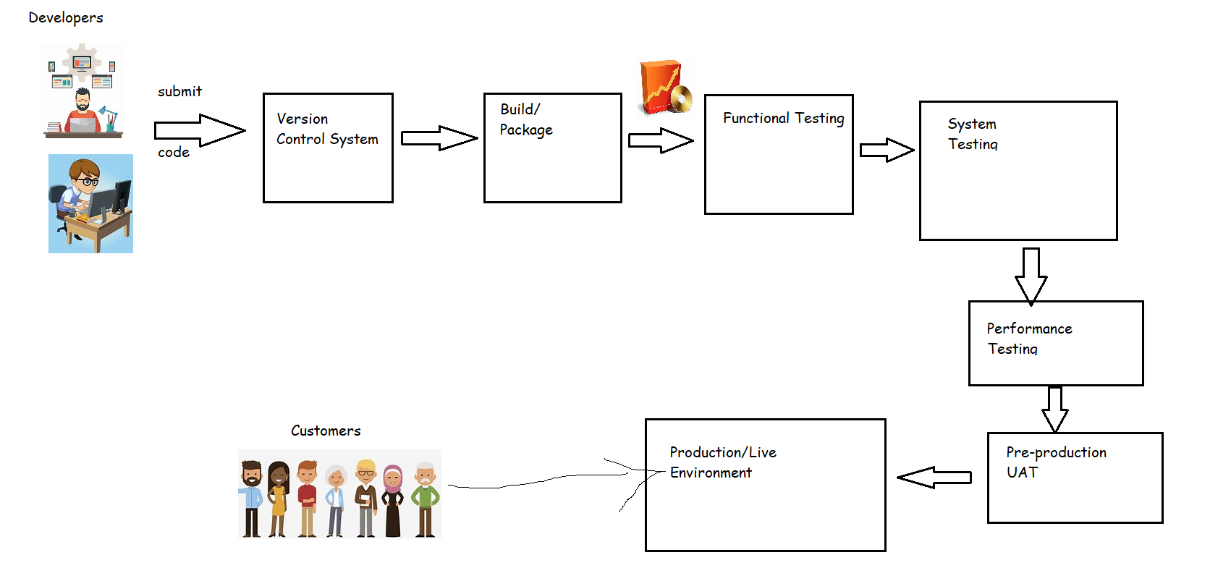
- As a DevOps Engineer, we need to automate the above workflow which is referred as pipeline.
  - Pipeline is sequence of steps which we need to perform to deploy your application/give feedback about the quality of the code submitted to your developer& others
  - Types of pipelines in DevOps
1) Continuous Integration.
2) Continuous Delivery
3) Continuous Deployment

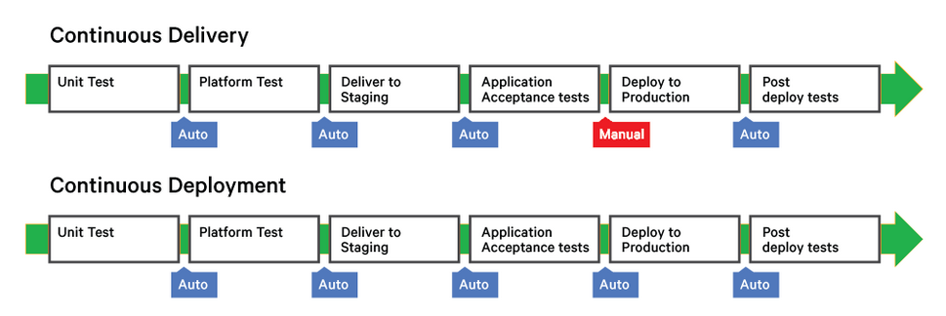
- DevOps Pipelines with tools
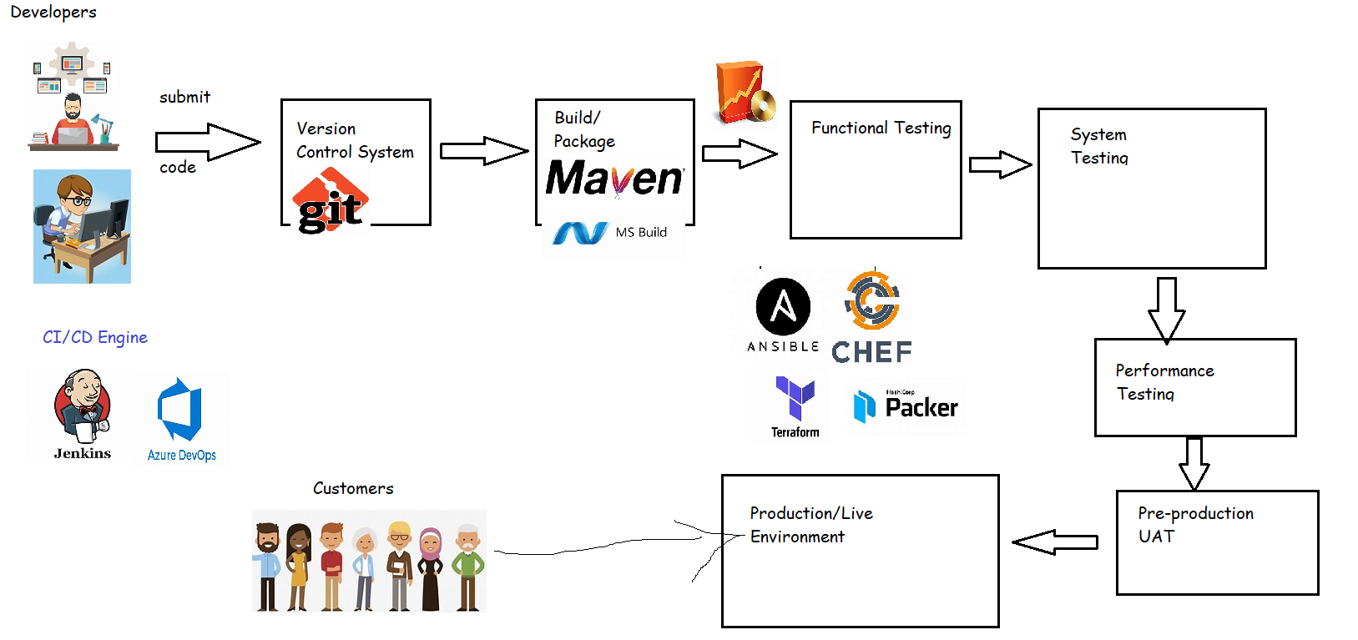
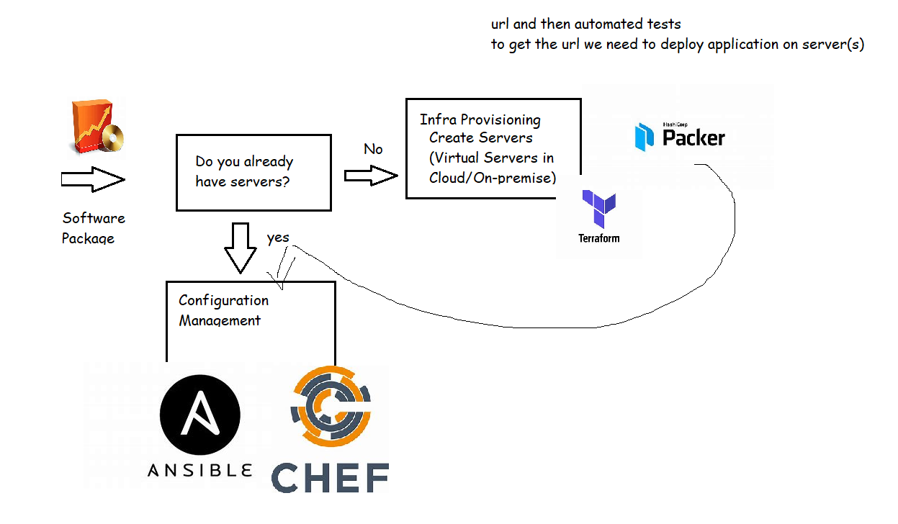

Devops with Monitoring tools
